

**Charity System Analysis**

**Software Engineering**

Prof. Amr Thabet

Assist. Lec. Shimaa Hagras

Ahmed Yasser Fathi Abdelhamied Sec - 1

Moaz Mohammed Samy Sec – 4

**CSED - 3**

**Intro:**

We all have volunteered someday. As volunteers, we saw that the regular systematic management system of charities devours a lot of time and effort. As a Software Engineering student, we tried to analyze charities' management systems. In the future, we plan to make a fully automated system. We Know that a charity is a gigantic system that has a lot of departments, operations, and people. All these components interact with each other in a very complicated way. So, we made a lot of constraints and tried to minimize the system to its core working blocks as this is V1.0 of this analysis. We also plan to extend this analysis when our experience gets more powerful.

**Description:**

A system that handles the operations inside a charity, going from the management head to the employees, and handling the donations and volunteering process to benefit the cases it observes and/or explores.

It handles (the finances between the management and employees), (logistics requesting funds), and (logistics exploring to find new rightful cases to help).

It also handles the status of the cases that have already been helped to make sure that these cases get the attention they need.

**User documentation:**

1. End-users:

a. Volunteers

b. Donors

c. Cases

1. Admin users:

a. Management

**Our system building blocks:**

* **Donors**: people who donate money or any other thing. they may set a date for a monthly donation.
* **Volunteers**: who works under the auspices of management.
* **Management**: paid or not. they are almost in charge of all things.
* **Cases**: any situation that charity can help with. It can by a mankind, mosque or a whole village.
* **Logistics**: almost anything management do.
* **Finance**: in charge of handling all resources.

**Our Analysis Constrains:**

AS we previously mentioned, we have made a lot of constrains, ignored a lot of department and operations, and merged a lot of roles and departments. In this section we will give examples of this constrains.

**Ignored Departments:**

* HR
* PR
* Media
* Partnerships

**Some of our Constrains:**

* Management does exploration.
* Management may have no salary.
* Age and gender may be null.

**Process of finding cases and helping them:**

* **Firstly,** the management needs to find a case that matches the criteria of cases that would require help.
* **Secondly**, the management sends back the information of the to handle the scouting process to see if the case is eligible for the charities' efforts of helping.

* **Thirdly**, If the case is eligible (under the standard criteria), the management department approves the process of help, hence, requesting the material it would need to start helping (money, food, clothes, etc...) from the finances department.
* **Fourthly**, the management starts gathering supplies that were requested in the logistics operations, then starts to assess the man-power it needs to start gathering volunteers that are willing to help from the department assigned to that specific case.
* **Finally**, a team consists of managements (Multiple*) and volunteers are assigned to this case with a date and time to start the final step of the process, coming back with a status of the case after helping, let that be (NEEDS FURTHER ATTENTION, NEEDS CHECKUP EVERY (time), CLOSED).

**Class Diagram:**

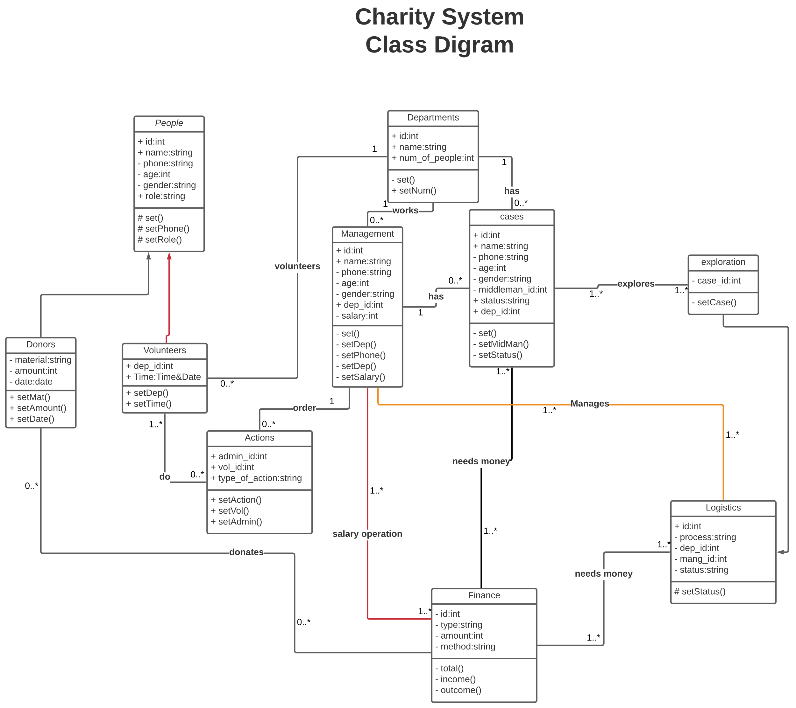

**Use Case Diagram:**

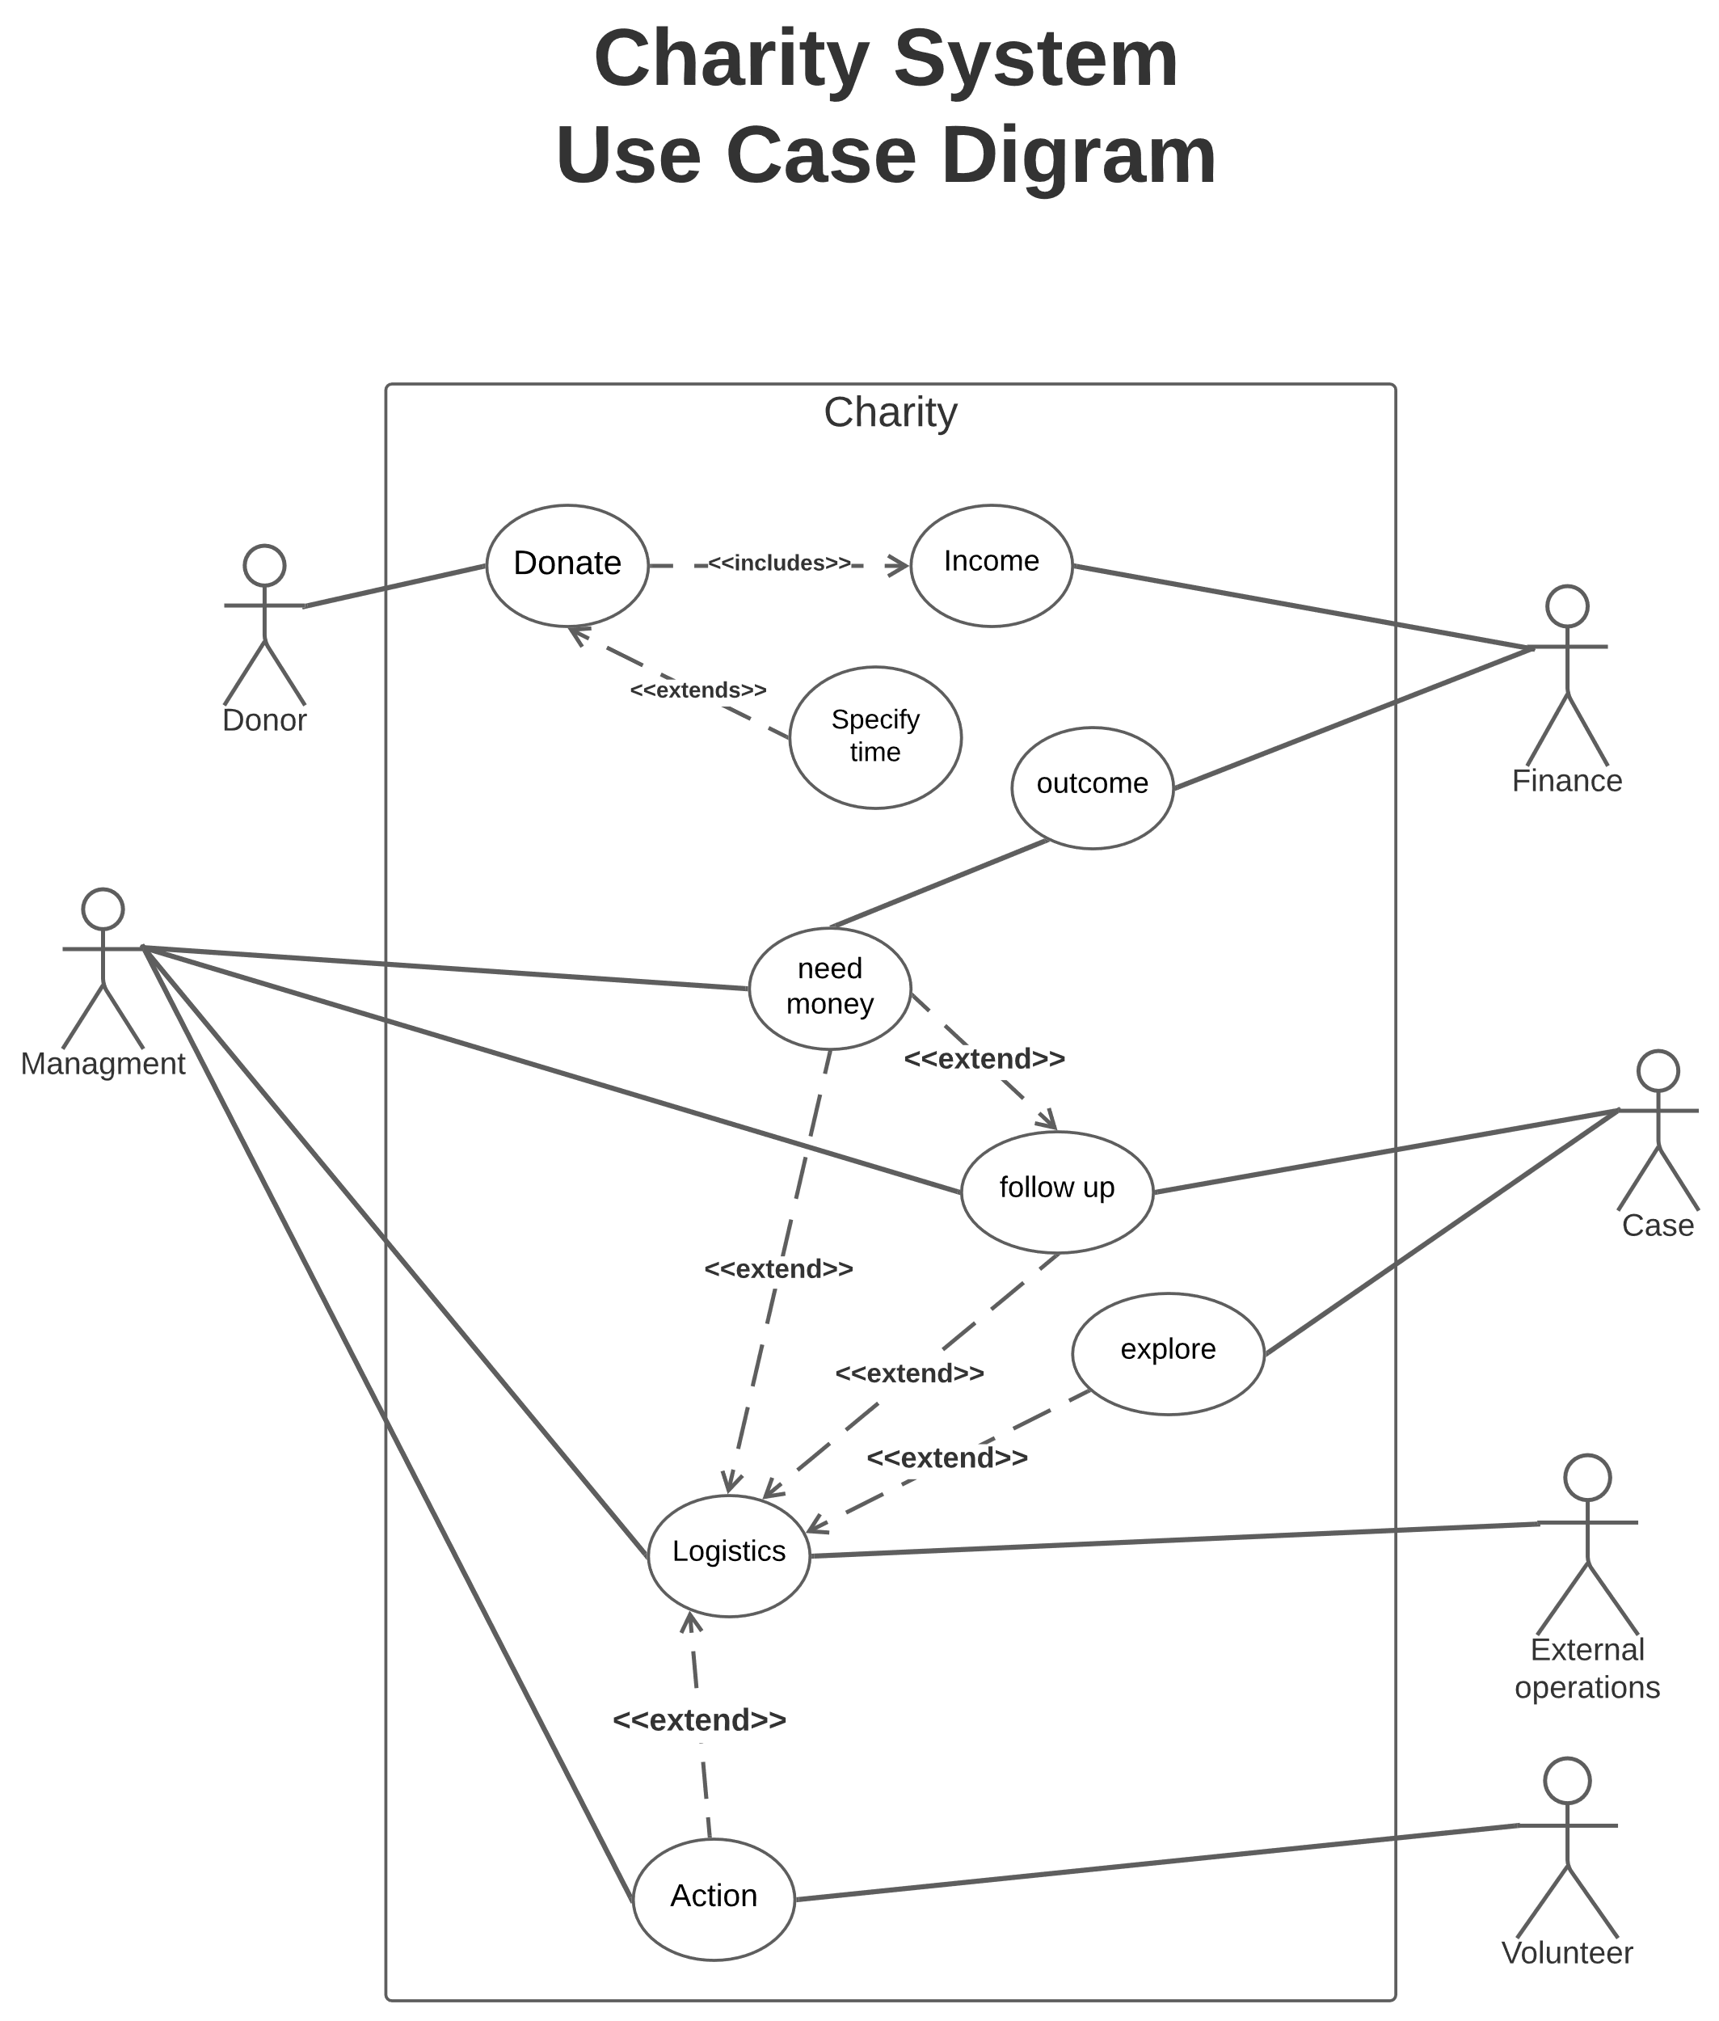

**Activity Diagram:**

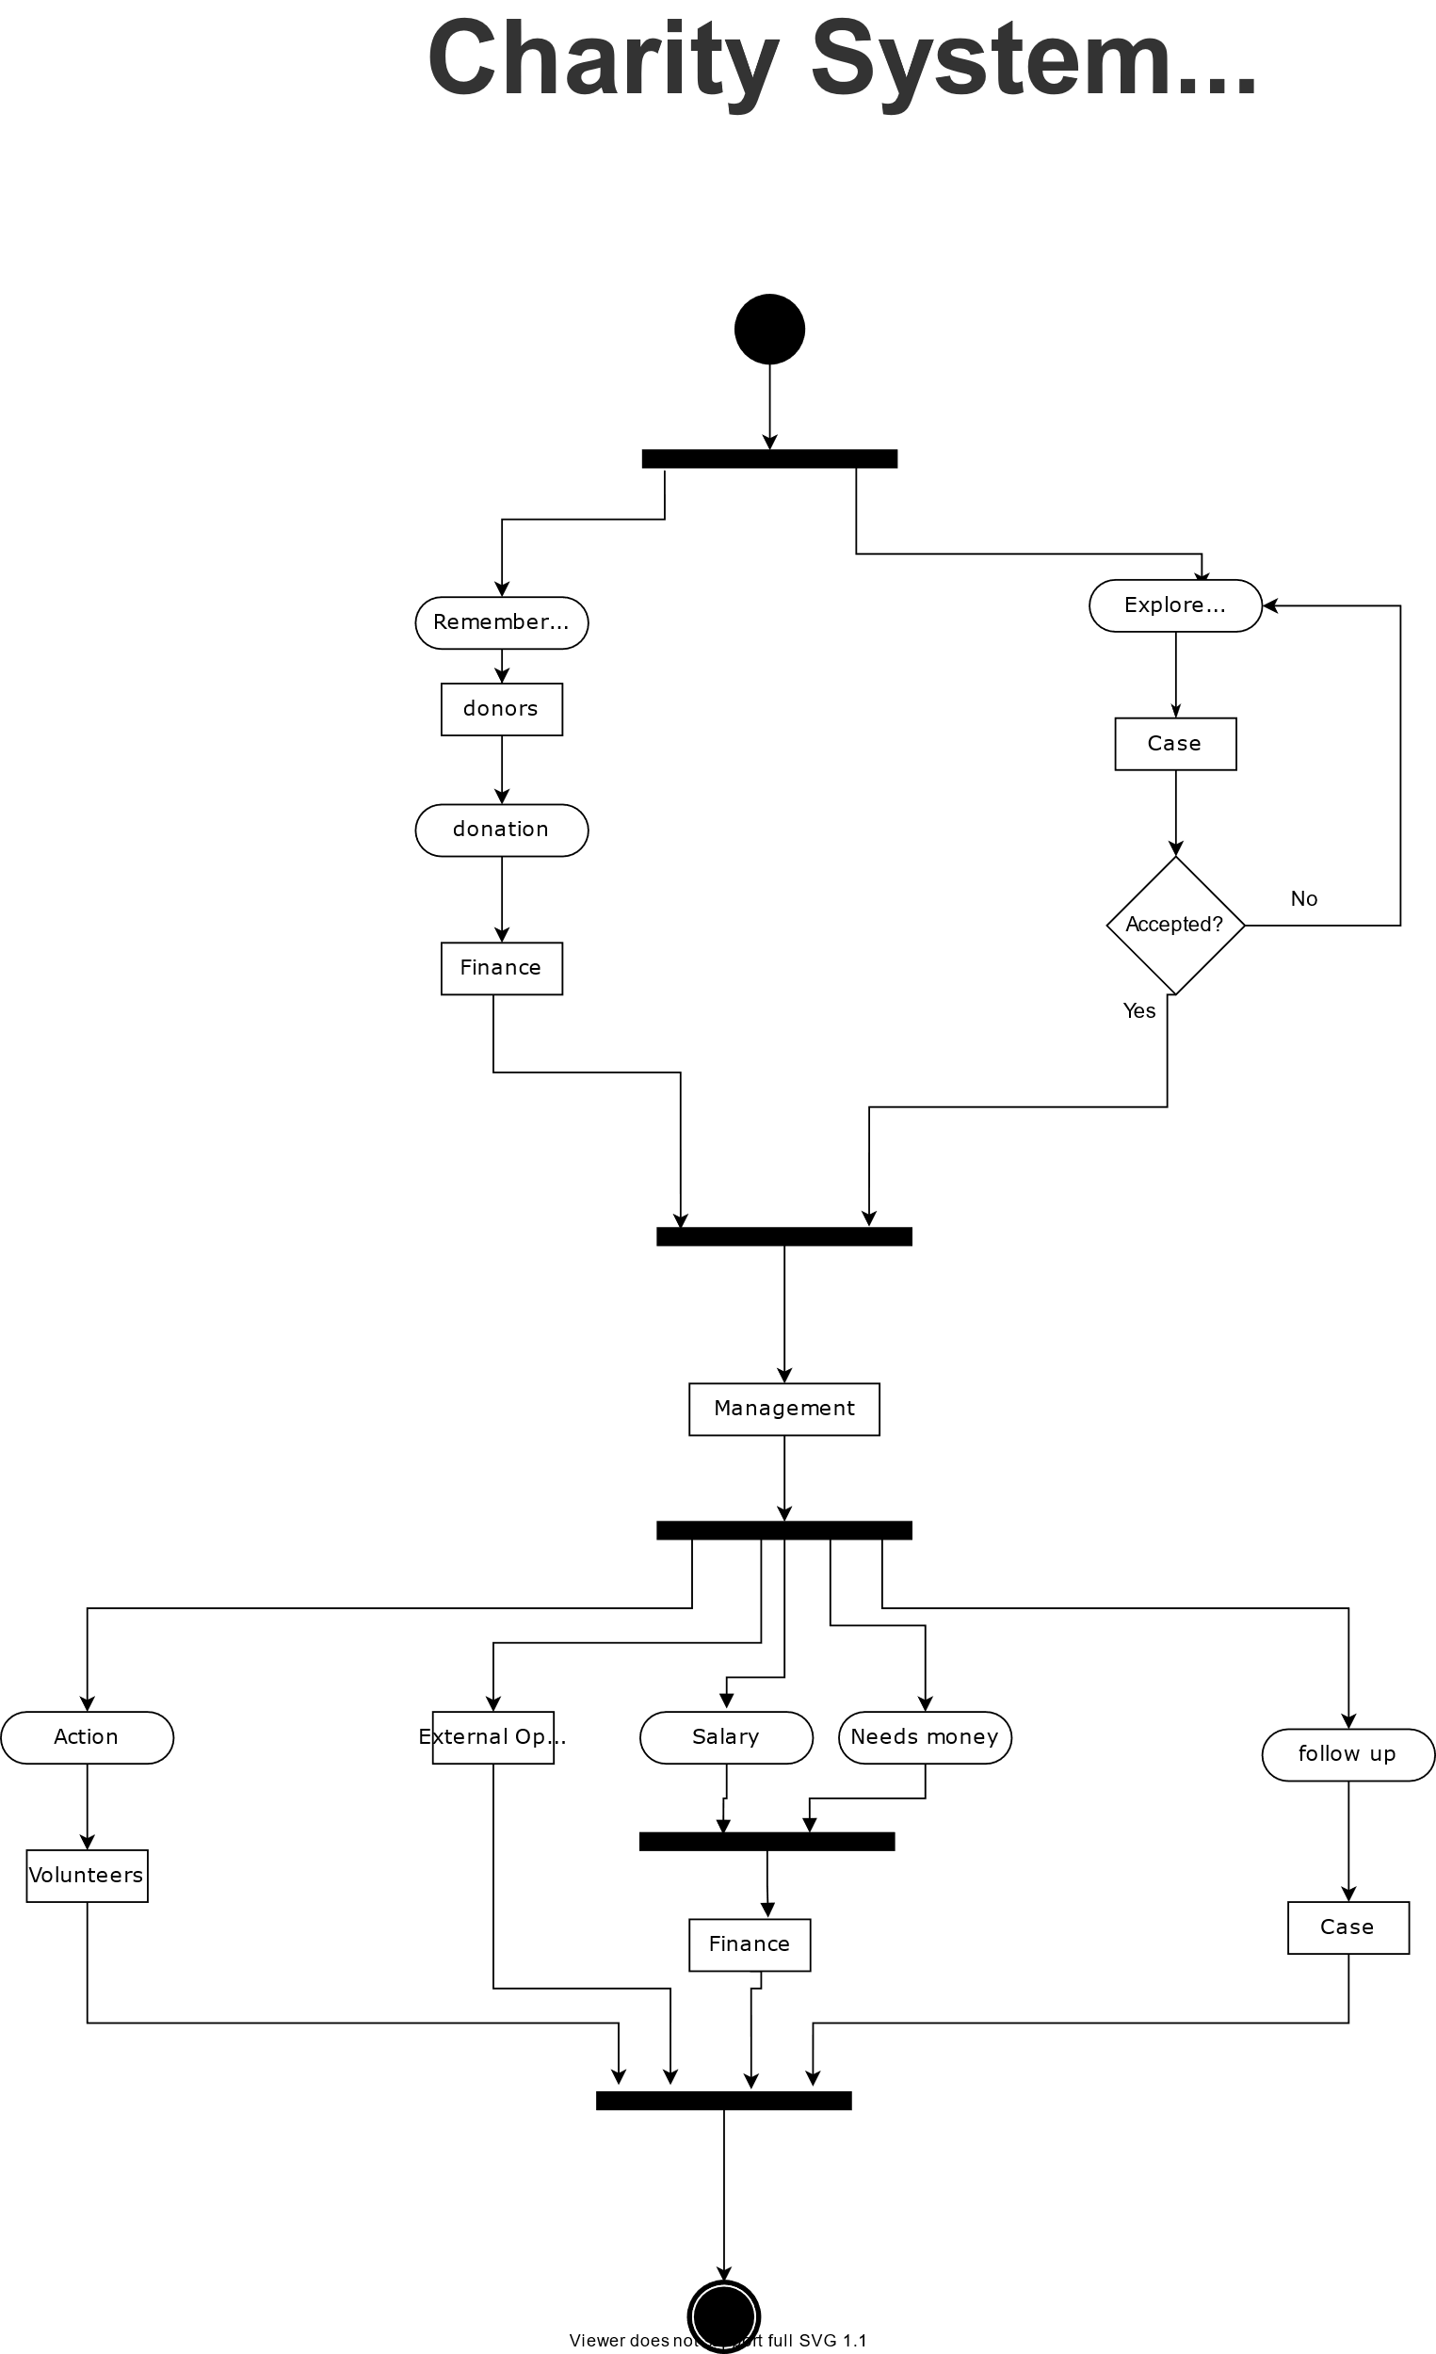

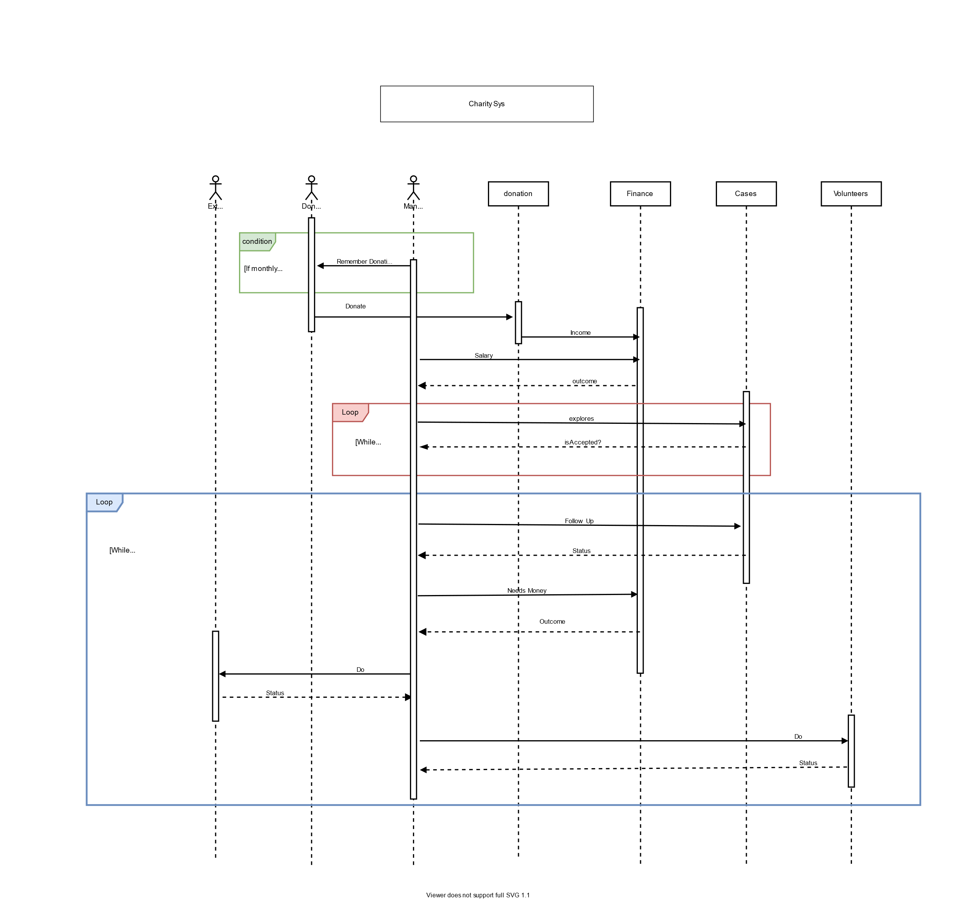**Sequence Diagram:**

**Risk Analysis:**

**Types of predicted Risks:**

1. Strategic.
2. Operational.
3. Hazard.
4. Financial.
5. Technical.

**Available Solutions:**

1. Avoid: eliminate cause of risk.
2. Mitigate: reduce probability or impact of risk.
3. Accept: continency plans for risk.
4. Transfer: have third party take on responsibility for risk.

**Risks**:

|  |  |  |  |
| --- | --- | --- | --- |
| Risk | Type | Probability | Effects |
| Exploration takes a long time | Operational | Moderate | Serious |
| Sol: Avoid. By putting deadlines for explorations and expand working teams. | | | |
| Lack of resources | Financial | Moderate | Catastrophic |
| Sol: Mitigate. Make marketing campaign, call our donors, make partnership | | | |
| Bad Management | Operational | High | Catastrophic |
| Sol: Avoid. Train managers, Hire highly skilled new ones. | | | |
| Lose connection with database | Technical | Low | Serious |
| Sol: Regular Maintenance, offline backup, keep hardcopies of data. | | | |
| Global Pandemic | Operational | Low | Catastrophic |
| Sol: Accept. precautionary measures, diversification of activities. | | | |
| Accounting problems | Financial | Moderate | Tolerable |
| Sol: Transfer. Hire an accounting company. | | | |